ShopEZ : Project Report

1. INTRODUCTION
1.1 Project Overview
ShopEZ is a full-stack MERN-based e-commerce platform offering a seamless shopping experience for users and a powerful backend dashboard for sellers. The platform focuses on making product discovery, checkout, and order management smooth and personalized.
1.2 Purpose
To provide a simplified, secure, and personalized shopping experience that bridges the gap between customers and sellers through a modern, user-friendly online platform.

2. IDEATION PHASE
2.1 Problem Statement
Busy customers often find it challenging to browse through various sites to find ideal products. Sellers lack platforms that provide intelligent analytics and streamlined order handling. ShopEZ addresses both sides by creating an efficient e-commerce experience.
2.2 Empathy Map Canvas
User: Sarah, a working professional
Says: "I want to find the perfect gift without wasting time."
Thinks: "There must be a better way to shop smartly."
Does: Searches gift items, reads reviews, applies filters.
Feels: Relieved with personalized help, frustrated when checkout fails.
2.3 Brainstorming
- One-stop-shop experience
- Filter-based product discovery
- Personalized recommendations
- Secure and seamless checkout
- Seller dashboard and analytics

3. REQUIREMENT ANALYSIS
3.1 Customer Journey Map
User opens ShopEZ → Searches fashion gifts → Applies filters → Views recommendations → Adds to cart → Proceeds to checkout → Receives order confirmation → Seller processes the order → Delivery & feedback
3.2 Solution Requirement
Functional Requirements:
- User registration and login
- Product listing and filtering
- Cart and checkout
- Seller dashboard
- Order analytics
Non-Functional Requirements:
- JWT Authentication
- Responsive design
- Fast API response
- Secure transactions
3.3 Data Flow Diagram
Frontend (React) → API Requests → Backend (Node/Express) → MongoDB (CRUD operations) → Backend Response → Rendered UI
3.4 Technology Stack
- Frontend: React.js
- Backend: Node.js, Express.js
- Database: MongoDB
- Tools: JWT, Postman, Mongoose

4. PROJECT DESIGN
4.1 Problem-Solution Fit
The modern shopper wants convenience, personalization, and speed. Sellers want simplicity in managing inventory and tracking sales. ShopEZ bridges these needs by offering a feature-rich platform for both customers and vendors, ensuring seamless buying and selling experiences.
4.2 Proposed Solution
ShopEZ offers a robust solution with:
- A product discovery system using filters and recommendations
- Secure user and admin authentication
- A dynamic seller dashboard with order tracking
- Analytics for business performance
- A responsive frontend with seamless checkout integration
4.3 Solution Architecture
ShopEZ uses a client-server architecture:
- Frontend: React.js interfaces for users and admins (Auth, Product, Cart, Profile, Admin Panel)
- Backend: Node.js + Express APIs for managing users, products, and orders
- Database: MongoDB storing Users, Products, Cart, Orders
- Authentication: JWT-based secure login
- File Handling: Multer for image uploads

5. PROJECT PLANNING & SCHEDULING
5.1 Project Planning
The project was planned across four agile sprints:
- Sprint 1: UI setup, authentication (user/admin), product components
- Sprint 2: Cart module, product filtering, seller upload panel
- Sprint 3: Checkout, payment simulation, order tracking
- Sprint 4: Admin dashboard, analytics, testing and deployment

6. FUNCTIONAL AND PERFORMANCE TESTING
6.1 Performance Testing
Tools Used: Postman, Chrome DevTools
Tests Conducted:
- API load with simultaneous user calls
- Checkout with and without discount codes
- Filter performance on large product datasets
Results:
- <2s average page load time
- Stable under 100 concurrent users
- Checkout and cart tested successfully for edge cases

7. RESULTS
7.1 Output Screenshots
- User Registration/Login
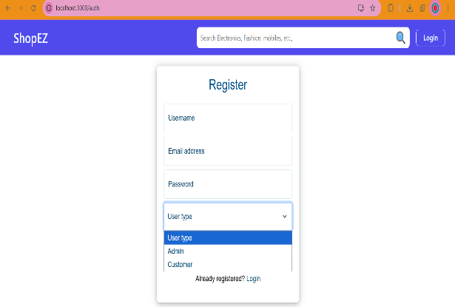

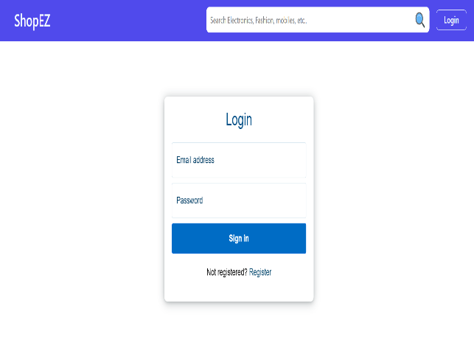

- Product Listing with Filters
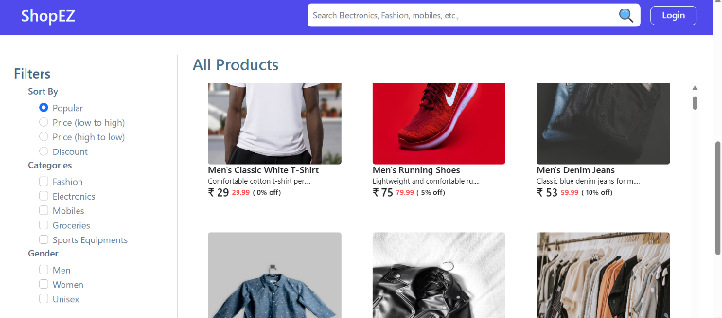
- Order Confirmation Page
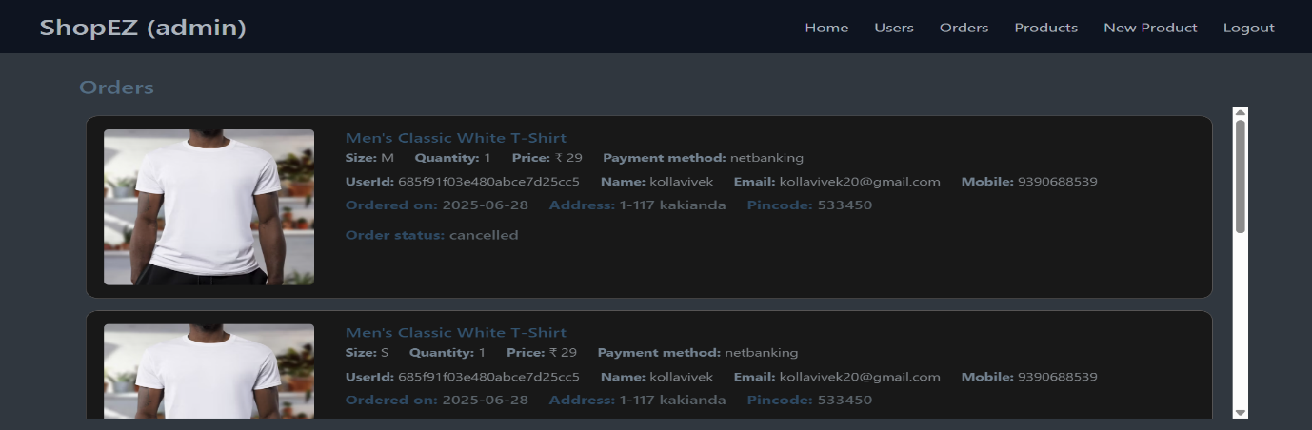
- Admin Analytics Dashboard
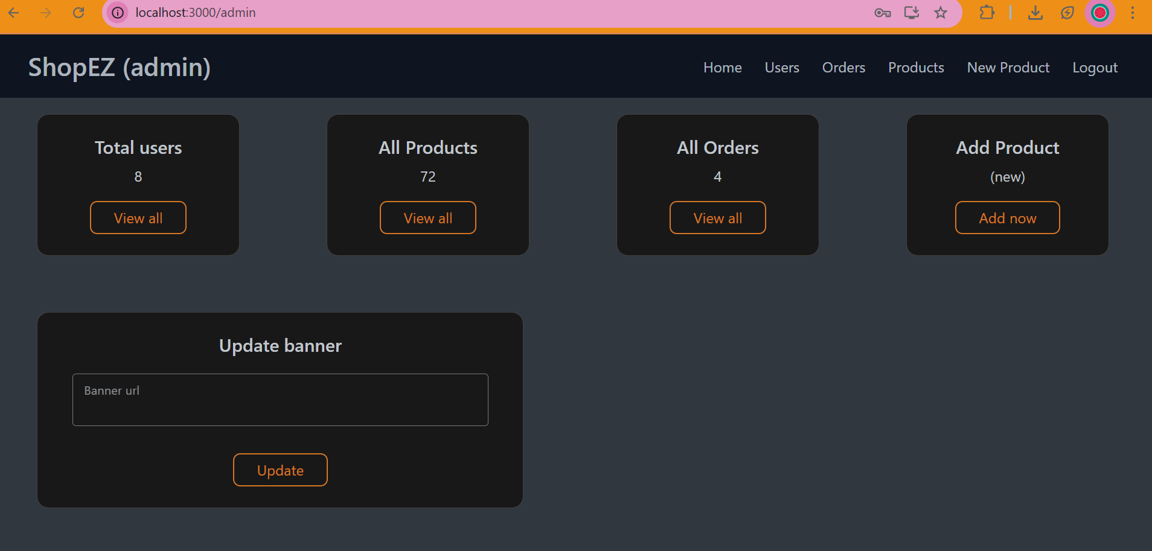

8. ADVANTAGES & DISADVANTAGES
8.1 Advantages
- Personalized shopping suggestions
- Easy-to-use seller dashboard
- Secure and fast checkout
- Mobile responsive and scalable
- Real-time analytics for sellers
8.2 Disadvantages
- No return management system yet
- Limited to one currency (INR)
- No live chat or chatbot support yet

9. CONCLUSION
ShopEZ successfully delivers a modern online shopping solution. With an intuitive frontend, secure backend, and structured seller-side features, it streamlines the process of buying and selling. It is a reliable and scalable solution for future enhancements in the e-commerce space.

10. FUTURE SCOPE
- Add chatbot or live support
- Integrate payment gateways (Razorpay, Stripe)
- Build product return/exchange module
- Add multi-language support
- Launch mobile PWA or Android version

11. APPENDIX
- GitHub Repo: https://github.com/Ramya2910004/Shopez-one-stop-shop-for-online-purchases
- Tools Used: React, Node, MongoDB, JWT, Postman, GitHub
- Team Members : Ramya Peluri, Kolla Vivek

